2.1.1 Customer Maintenance
1. We maintain a new customer in this function by creation of completely new customer number.

Customer – there is CZ (domain 200) number range 629 + arrow up = then you get the last already existing customer number, now it is 62115730 + 10 = new customer number is 62115740
So, it depends which number range you have in your NL domain 1400.
The system of getting a new customer number should be the same.

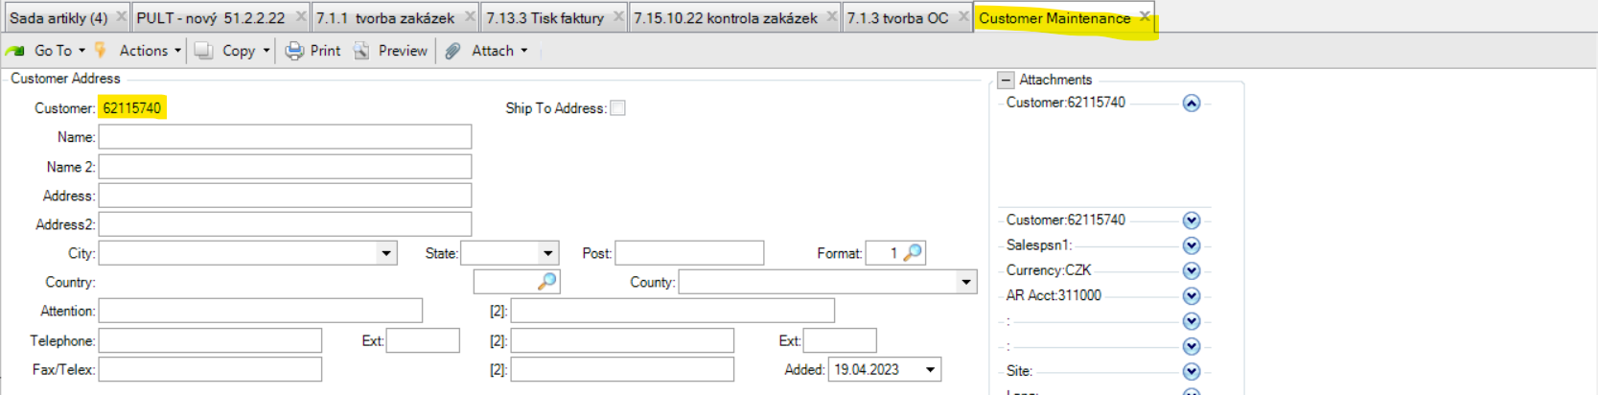

2. Or we can just maintain here a new customer number from registration via our web site.
We usually receive information about a new registration by checking function 2.1.2 (51.2.5.1 – validated No).
Customer – customer number (existing from registration or creation of a new one)
Name + Name 2 – customer name (there is a limited space in each field, you can continue on 2)
Address + Address 2 – street (there is a limited space in each field, you can continue on 2)
City, Country, Telephon, State – it is clear
Attention – contact person
Post – postal code
(2) – email address
Sort Name – seaching term
Salespsn1 – sales representant number + Multiple – means more sales representant number
Ship Via – type of transportation
AR Acct - analytic account (311300) + cost centrum (3000) – NL will have own codes for this purpose
Remarks – default note which is visible in each future sales order , basically for your usage (you can mention „payment in advance 0-0-0“ to directly see it when processing order)
Type – accounts receivable (each branch has it´s own code here)
Region – country code
Currency – EUR
Site – code of CZ warehouse (I gues you will have a different Site, might be 140)
Lang – your communication language in QAD (US = english)
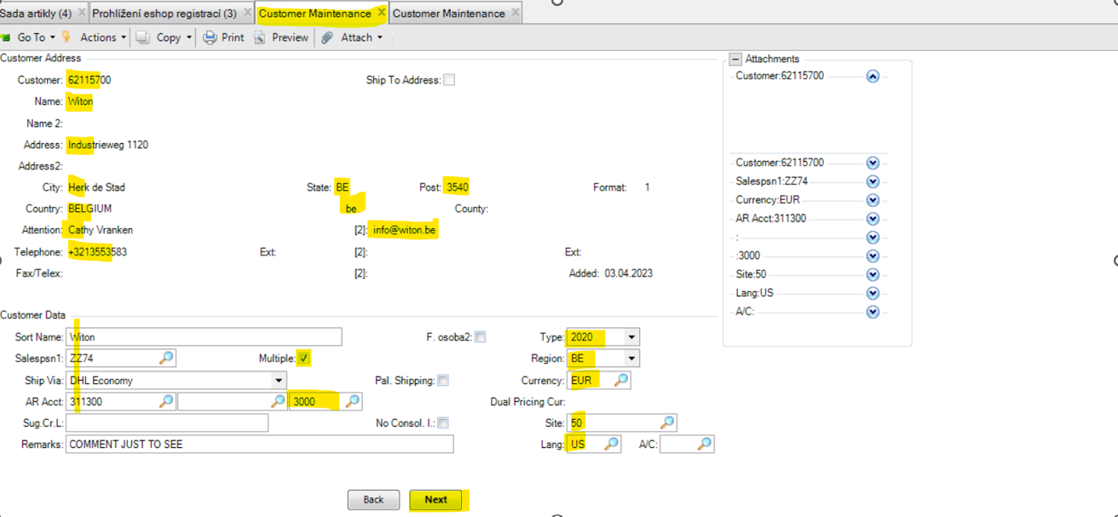

Multiple – clicked box means you can add more sales persons who are in charge for particular client
Salesperson 2 – is used for the customer service assistand in HRX HQ. Ger has required to use here e.g. NL North + NL South (if people leave we need to update Salesperson/s, but with South and North that is not the case...just to make it simple).
+ Next
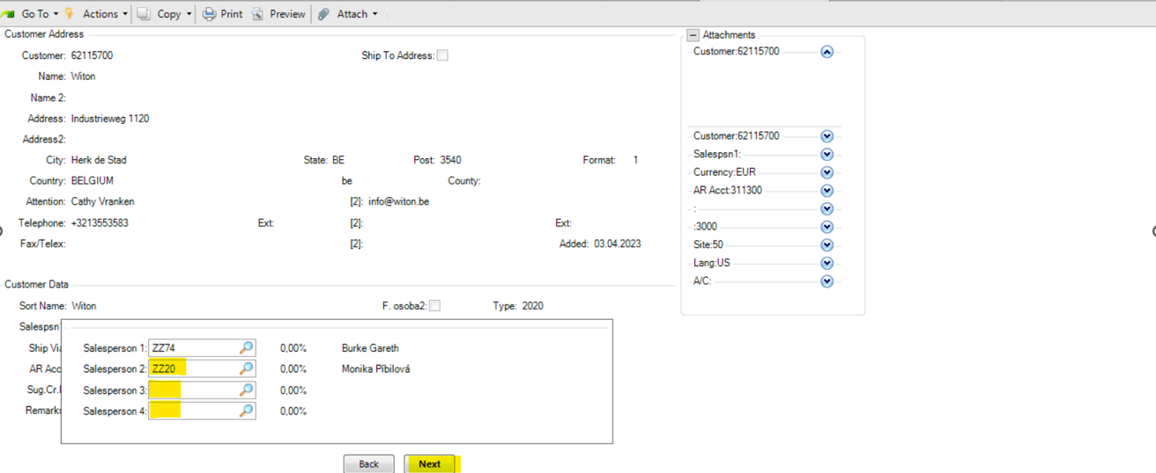
Fixed Price – we don´t work with a connection to this field, can be cliked or uncliked, does nothing
Certification – means that customer is certified to sell FSC goods
Registered – means that customer made registration via e-shop
Validated – if it is validated, it primarily uses the payment method from 2.1.1 when customer ordering via e-shop (if the customer is not validated, the payment conditions will be displayed on the e-shop just as: payment in advance 0-0-0, cash on delivery and cash). We usually validate the customer after all data and settings are done on our side.
Partial OK – says if customer agrees with partial deliveries (at least that´s how I understand it )
Green box - Clicked on Germany side, let´s discuss with them what does it mean and for what purpose they use it for.
+ Next
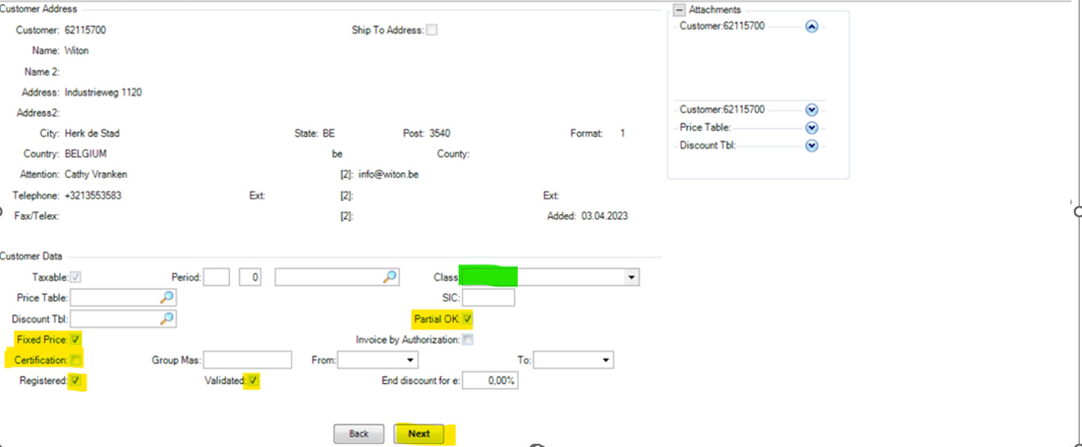
Tax Zone – accounting information, NL will use their own code, might be just NL
Tax Class – accounting information, NL will use their own code
Tax Usage – accounting information, might stay as blank in NL (the same it is on German side)
Vat Number - has to be filled after the VAT number is verified via VIES VAT number validation.
Green boxes - I can see them clicked on Germany side, let´s discuss with them what do they mean and for what purpose do they use them for.
+ Next
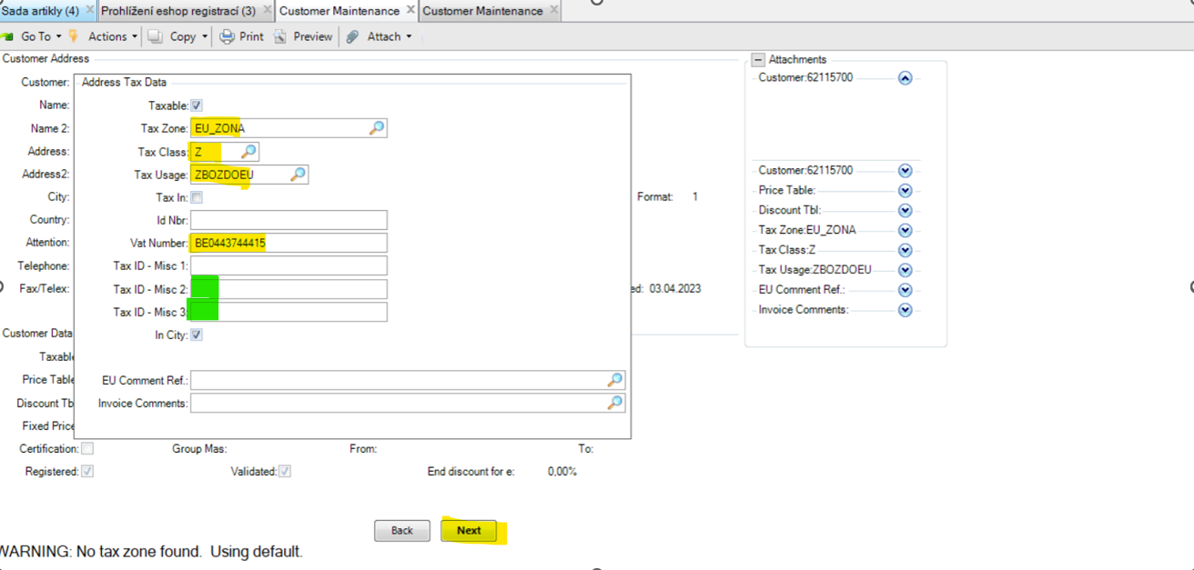
The VIES electronic system is used to verify the tax identification numbers of economic operators registered in the European Union for the purposes of cross-border transactions in goods and services.
Kindly note that we (as HRX HQ) charge VAT only to customers which are not verifyied in VIES. 😊
If customer is varifyied as below, we do not charge VAT.
https://ec.europa.eu/taxation_customs/vies/#/vat-validation
note: don´t use the country code before VAT number when veryfiing

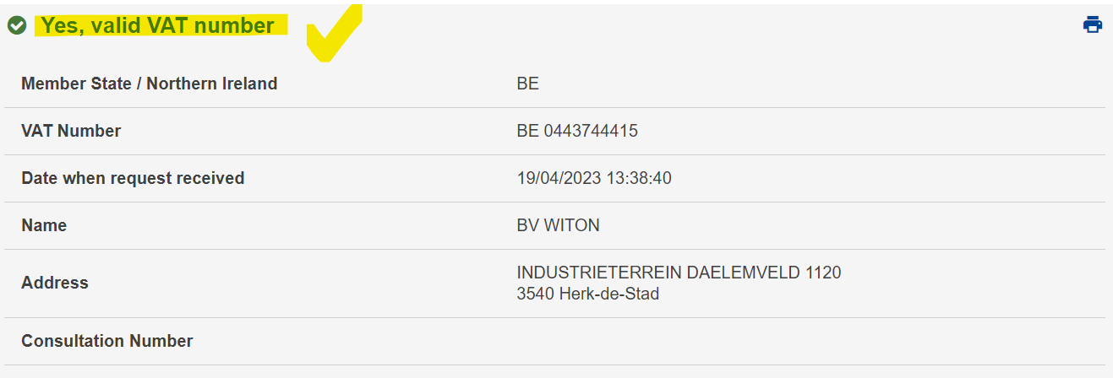
Bank – code for the bank (I guess, you will have your own codes)
Payment Method – SE means in EU, FE means out of EU (I guess, you will have your own codes)
+ Next
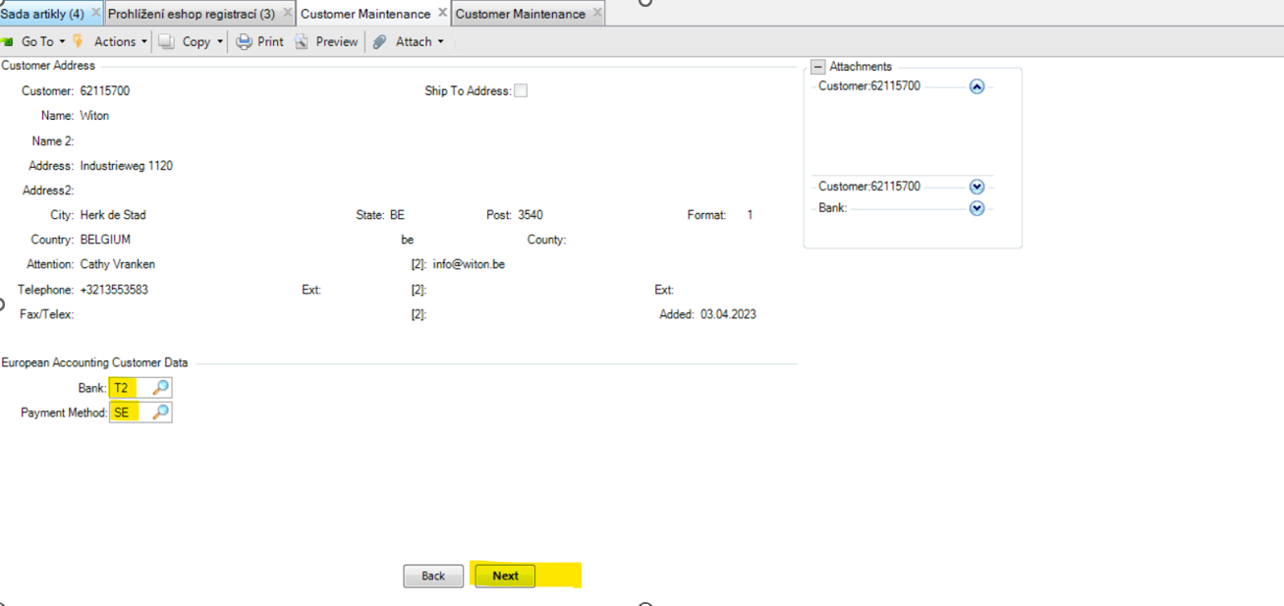

Terms – payment terms (this field is directly linked with the box Validated = means that will be defaulty and primerly set in e-shop)
DB Number – Incoterms (DAP, FCA, …) + city of delivery
Bill to – payer, it is linked to Sold to party number, it has to be filled
Green boxes – I can see them clicked on Germany side, let´s discuss with them what for what purpose do they use them for.
+ Next
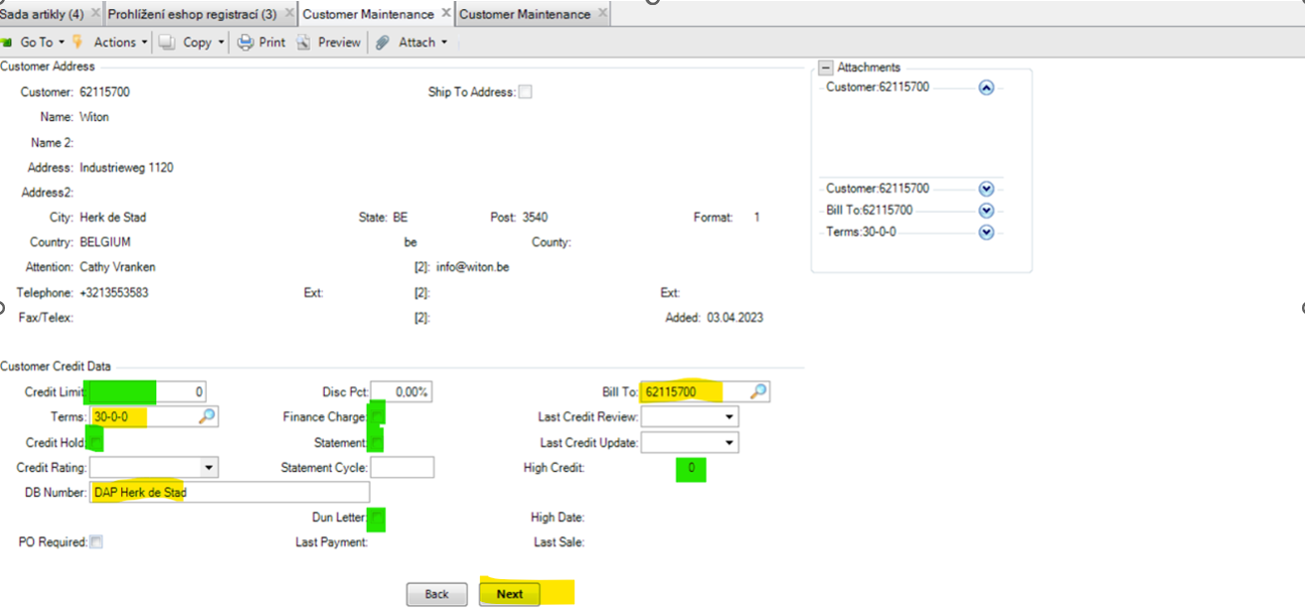

Join – if customer allows a join in the roll
Pallet type – dimension of pallet which is allowed to use for this client (it possible to write down just one option, it is not ideal for our usage)
Limit - is the price (value of sales orders) up to which customer has to pay the transportation
+ Next
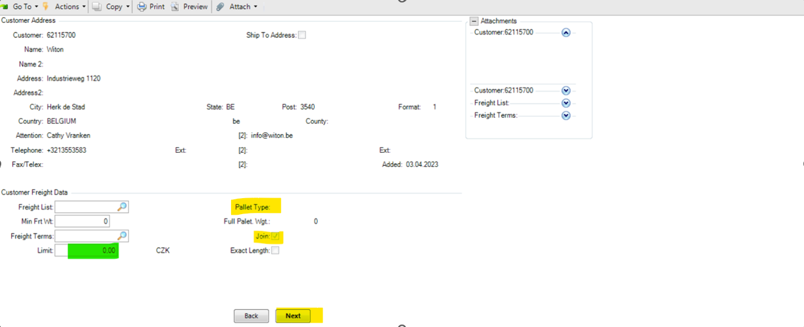

EMT Type – automatically inserted record, skip it
+ Next
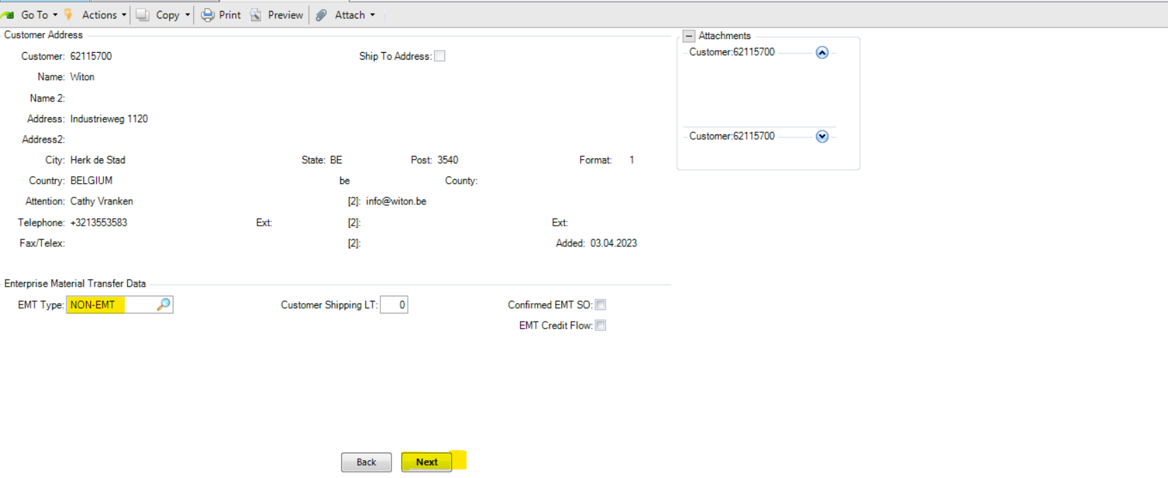

Bank – customer´s bank account (not mandatory field)
Acct. Type – account type (not mandatory field)
+ Next
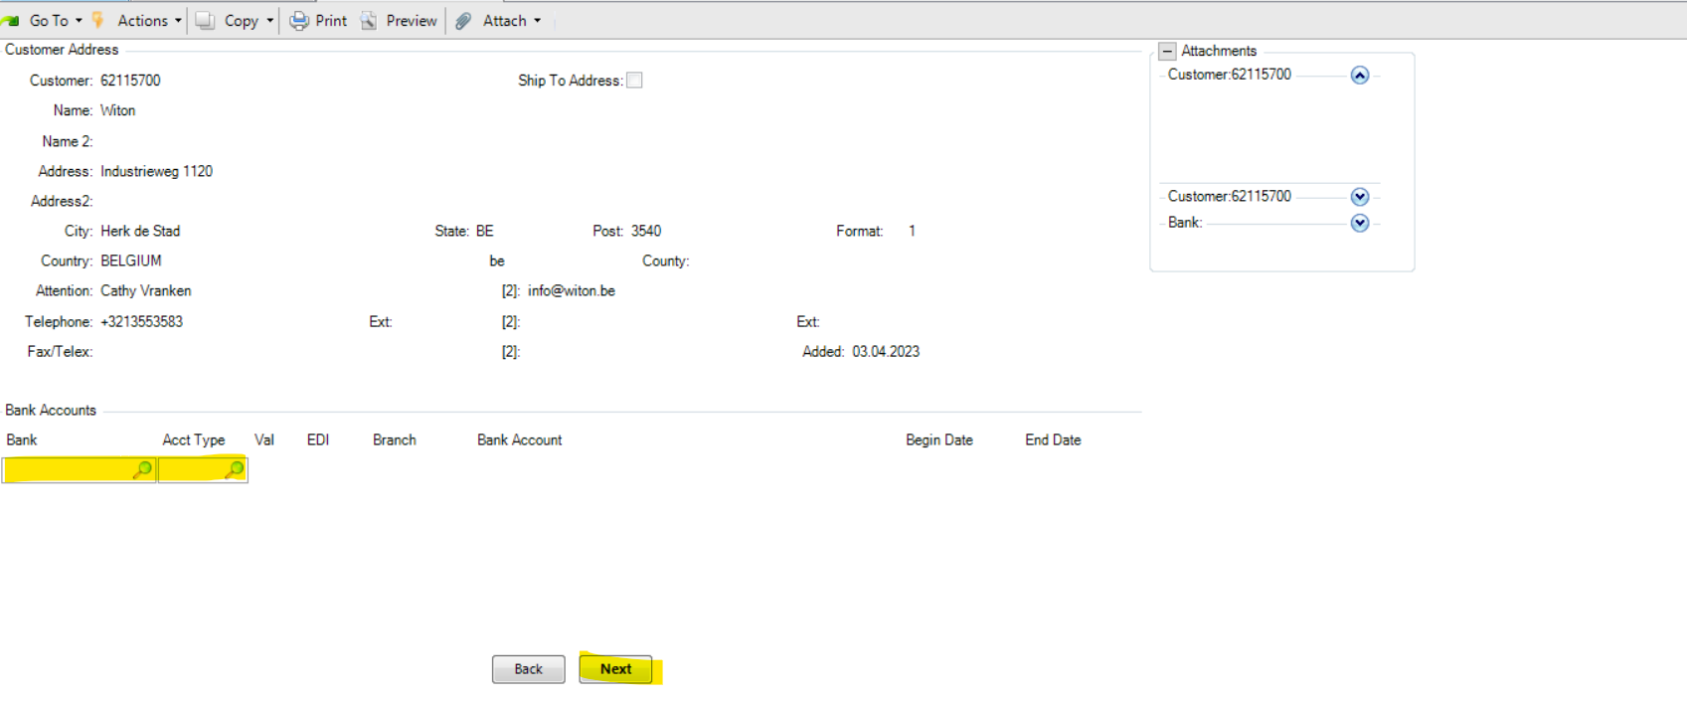
Click on the table = OK + BACK – then you are returned to the first page of customer maintencance
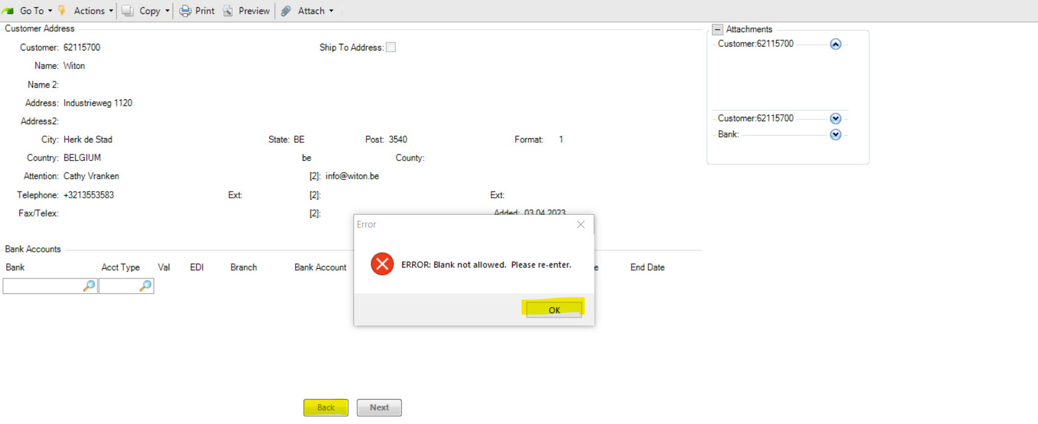

To finalize and make the new customer as functional, we have to set yet:
1) 36.21.12.1 Change EAN of partner
2) 36.21.1 Parametrs of Partner – Maintenance
3) 2.1.8.10 Customer Price Report
4) 1.12 Text maintencance
4) + do settings in QAD CRM

See further manuals.

